**RESUME**

Name-**Sudip Kumar Dash** 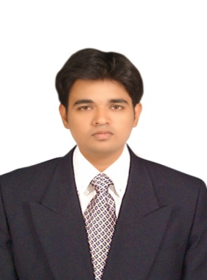

[Email-**sudipdash95@gmail.com**](mailto:Email-sudipdash95@gmail.com)

Mob-**8763790961,7077006342**

DOB-: **11/01/1995**

**OBJECTIVE**

To be an effective & efficiency mechanical engineer in an industry and expert on the available technologies & significant contributor to growth of organization & myself.

**EDUCATIONAL QUALIFICATION**

|  |  |  |  |  |
| --- | --- | --- | --- | --- |
| **Examination passed** | **Name of the Institution** | **Board/University** | **Year of passing** | **Percentage/Cgpa** |
| B-Tech in Mechanical Engineering | GITA ,Bhubaneswar | BPUT University | 2018 | 7.9 CGPA |
| Diploma in Mechanical  Engineering | Hi-techInstitute of Technology  ,Khurda,Bhubaneswar | SCTE&VT Odisha | 2015 | 72.53% |
| +2 science | Alaka Mahabidyalay ,Jagatsinghpur | CHSE ODISHA | 2012 | 48% |
| Matriculation | Purohitpur High school, Jagatsinghpur | BSE , Odisha | 2010 | 70% |

# **PROJECT PROFILE**

B-tech project: - Portable multi forming operational machine.

Diploma Minor Project:-Refrigeration and Air conditioning.

**COMPUTER SKILLS**

* Operating Systems: Windows XP/Vista/7/8.
* Other soft wares: MS office & c

**LANGUAGES**

* **Speak**: English, Hindi and Oriya.
* **Write**: English, Hindi and Oriya..

**AREA OF INTEREST& HOBBIES**

**Academics**: Automobile & IC Engine.

**Sports**: Cricket

**Strength:** Honesty, leadership quality, flexibility in my field, hard & smart working ability.

**SUMMER TRAINING:**

* Internship at **Rourkela Steel Plant** on “**coke ovens**”
* Industrial visit to **Mancheswar railway workshop**

**SEMINARS & WORKSHOPS:**

* Workshop on CAD/CAM and CNC Technology at CTTC ,BBSR
* National seminar on “**Recent Advancement In Mechanical Engineering & Engineering Materials**” .
* National seminar on “ **Bharat stage emission standards**” by **TATA Motors**

**PERSONAL SKILLS**

* Hard working.
* Good at team work.
* Comprehensive problem solving abilities.
* Adaptability to work in different situations.
* Willingness to learn.

**PERSONAL DETAILS**

* Father Name & occupation- Rabinarayan Dash & Businessman
* Name- Sudip Kumar Dash
* Contact add- Nangloi ,House no-5,N block ,camp no 3 ,pin -110041 new delhi

**DECLARATION:**

I hereby declare that the above written particulars are true to the best of my knowledge and belief.

Date

Place signature